SUBJECT AREAS 62nd INTERNATIONAL CONGRESS OF NAVAL ARCHITECTURE,
MARINE TECHNOLOGY AND MARITIME INDSTRY
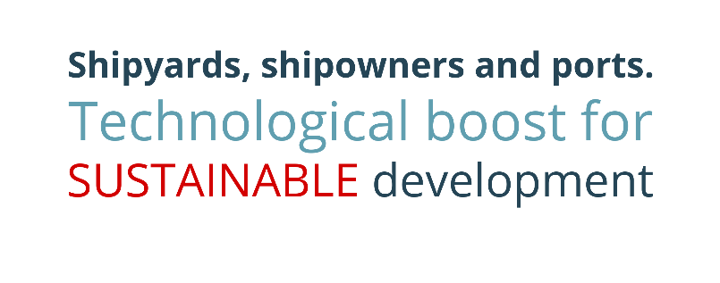
The subject areas to be discussed at the congress, without limitation, are:

Energy transition:
- Decarbonization objective
- Offshore wind power
- Use of traditional and alternative energy sources in the generation and propulsion of vessels and port facilities: New fuels, fuel cells and energy storage systems.

Reindustrialization:
- Impact on the Hinterland and the auxiliary industry.
- Strategic knowledge for the achievement of projects of the shipbuilding.
- Digital transformation of shipyards: Shipyard 4.0.
- Modernization of the shipbuilding industry.
- Post COVID working model.
- Economic recovery of the maritime industry, market situation and effect on companies and professionals.
- Retrofitting, repair shipyards and scrapping.
- Innovative equipment and facilities.

Blue economy:
- Aquaculture.
- Sustainable fishing
- Ocean Platforms
- Cruises
- Pleasure crafts
- Mega yacht: Repairs and transformations.
- Waste management

Military shipbuilding:
- New challenges in maritime safety and security.
- Integrated surveillance systems
- Vessels for the fight against piracy and humanitarian aid to migration.

Maritime transport:
- Infrastructures and accesses.
- Port services.
- Passenger traffic and ro-ro cargo.
- Container traffic.
- Congestion in logistics.

History and naval heritage:
- Historic ships and the preservation of traditional vessels.
- Contribution of naval engineers to Spain and Society.

